To: Professor Andy Ross

From: Dream Footwear | Antoni Díaz (CEO/CFO), Dani Guandique (CMO), Kyle Porter (COO)

Date: April 16th, 2024

Re: Dream Footwear Strategic Plan

**Company Overview**

**Executive Summary**

In the past four years, Dream Footwear has demonstrated remarkable growth in net revenues, showcasing our commitment to delivering value to our customers and stakeholders. Building upon this solid foundation, we have achieved consecutive year-over-year increases, with a noteworthy 71.69% overall net revenue growth since Year 10. This consistent growth trajectory reflects the effectiveness of our strategic initiatives and operational excellence. Despite facing challenges in the economic landscape, such as the slight decrease to 7.81% in Year 13, we swiftly regained momentum and jumped back on track with a remarkable 19.11% increase in Year 14. Our ability to rebound demonstrates the resilience and adaptability of our business model. As we embark on the next 3 years, we remain focused on leveraging our strengths, addressing key strategic issues, and capitalizing on opportunities for continued growth and success in the dynamic footwear market. For more information, review the Year-Over-Year Net Revenue Growth Percentages (Figure 1.1) and Revenue Growth Chart (Figure 1.2).

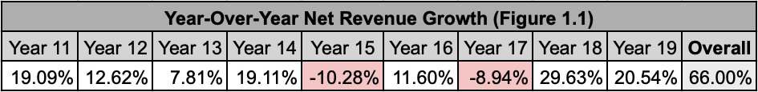

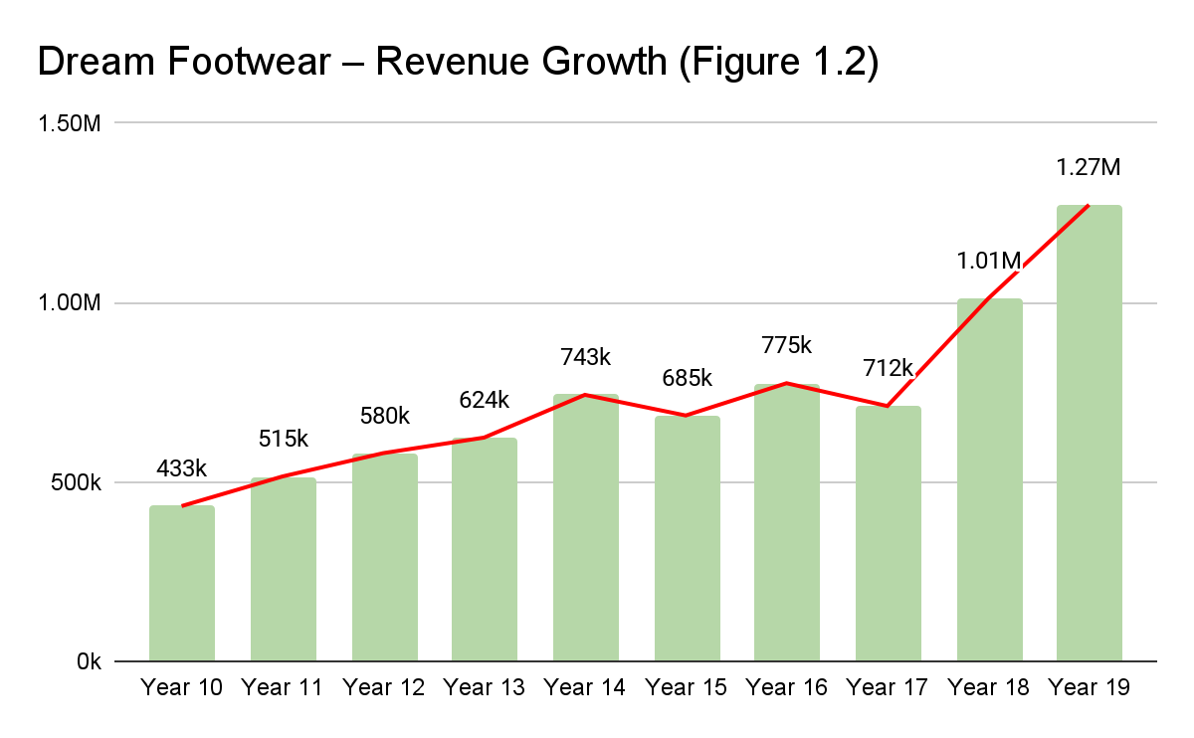

**Vision**

Our vision is to be the go-to brand for affordable, quality athletic footwear making active lifestyles achievable to everyone around the globe. Dream Big, Dream Comfort, Dream Footwear!

**Mission Statement**

At Dream Footwear, we are innovators, designers, and champions of active living, dedicated to providing athletes and fitness enthusiasts of all levels with high-quality, sustainable athletic footwear. Our mission is to empower every individual to reach their peak performance and support their journey towards a healthier, more active lifestyle. We do this by leveraging cutting-edge technology, sustainable materials, and inclusive design to create footwear that not only boosts performance but also champions the health of our planet and the diverse needs of our global community. Why are we here? To inspire movement, foster environmental stewardship, and celebrate the spirit of athleticism in everyone, everywhere.

**Core Values**

Through these core values, Dream Footwear communicates our commitment to being more than just a footwear company. We are a brand that stands for ethical practices, innovation, inclusivity, customer satisfaction, and the level of transparency not many others can compete with. Our broad low-cost strategy mixed with a best-cost strategy hybrid is not merely about offering affordable products; it's about making a positive impact on the lives of our customers and the world at large, ensuring that high-quality athletic footwear is accessible to all.

Innovation and Excellence: We strive to redefine what's possible in athletic footwear, constantly pushing the boundaries of design, functionality, and affordability. Our focus on innovation drives us to develop products that meet the high standards of excellence our customers deserve, without the high price tag. By leveraging cutting-edge technology and creative design thinking, we ensure that excellence in quality and performance is accessible to everyone.

Inclusivity and Diversity: At Dream Footwear, we celebrate the diversity of our customers and the global community. We are committed to creating products that cater to athletes of all backgrounds, abilities, and needs. Our approach to inclusivity extends beyond our product line to encompass our corporate culture and the partnerships we forge, promoting a world where everyone has the opportunity to achieve their athletic goals.

Customer-Centricity: Our customers are at the heart of everything we do. We are dedicated to understanding their needs, aspirations, and challenges. This customer-centric approach informs our product development, marketing strategies, and customer service. By listening to and valuing our customers' feedback, we ensure that we not only meet but exceed their expectations, providing them with affordable footwear that does not compromise on quality or style.

Integrity and Transparency: Dream Footwear is built on a foundation of honesty and openness. We believe in doing business ethically, making decisions that are not only good for our bottom line but also right for our customers and the community. Our commitment to transparency means we are open about our manufacturing processes, pricing strategies, and the efforts we make to sustainably source materials. We hold ourselves accountable to our stakeholders, ensuring they can trust us to act with integrity in all our endeavors.

**Analysis and Objectives for Y18-Y20**

Presented in this section is a comprehensive analysis of Dream Footwear's performance in the previous years, starting in Year 10, highlighting the company's journey towards a successful future culminating in Year 20, with a focus on key measures of success including *Earnings Per Share (EPS), Return on Equity (ROE), Stock Price, Credit Rating, and Image Rating*. Dream Footwear's strategic initiatives, resilience, and continuous improvement efforts have resulted in a positive trajectory, especially notable since Year 17. Sustaining this growth momentum and strategic focus will be crucial for the company's long-term success and competitiveness in the market. For a deeper understanding of year-over-year data on the five important measures, review ‘Five Important Measures of Success’, Figure 1.3.

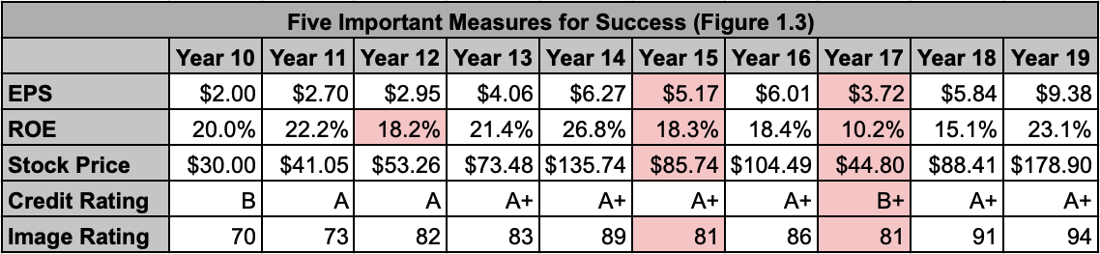

Dream Footwear's financial performance from Years 14 to 19 showcases a journey marked by both challenges and significant improvements, particularly noteworthy since Year 17. The company faced fluctuations in the five important measures. Notably, there was a dip in **EPS** in Year 17 to $3.72, reflecting a temporary setback in profitability. However, Dream Footwear quickly rebounded and achieved remarkable growth, reaching an EPS of $9.38 by Year 19, indicating a robust recovery and enhanced profitability. Based on performance in Year 18 and 19, we are expecting a continuation of steady improvements in our EPS as we approach Year 20.

Similarly, the company's **ROE** experienced dips in Years 12 and 15, highlighting challenges in maximizing returns relative to shareholders' equity during those periods. Despite these fluctuations, Dream Footwear stabilized its ROE and significantly improved to 23.1% by Year 19, demonstrating effective utilization of equity and increased profitability over time. We expect huge improvements in our ROE, with continuing plans of selling stock and buying dividends.

**Stock price** performance witnessed notable fluctuations, with a significant dip in Year 17 to $44.80. However, the company's resilience and strategic initiatives led to a substantial recovery, with the stock price soaring to $178.90 by Year 19. This impressive growth reflects investor confidence, market performance, and the company's ability to navigate challenges effectively. Our stock price is predicted to continue rising on a yearly basis as we approach Year 20, and expect no change here aside from an upward trend in numbers.

Furthermore, Dream Footwear's **credit rating** dipped to B+ in Year 17 but swiftly recovered to an A+ rating by Year 19. This recovery emphasizes the company's strengthened financial stability, improved creditworthiness, and favorable borrowing terms, contributing to investor trust and confidence in the company's financial health. A significant boost in credit rating is predicted as we will not be taking out any additional loans for the foreseeable future.

Lastly, the company's **image rating** fluctuated over the years, experiencing a dip in Year 15 but steadily recovering and significantly improving to 94 by Year 19. This upward trajectory in brand perception signifies Dream Footwear's successful efforts in enhancing its market positioning, customer trust, and overall brand reputation. In addition, Dream Footwear has acquired three new celebrities, as we have deemed necessary for more growth and brand recognition after having no celebrities in Year 17.

**Overview Strategic Initiatives**

Marketing: After experiencing challenges in previous years, we made a strategic decision to adopt an aggressive approach to market penetration. Recognizing the limitations of our previous defensive marketing strategy, particularly in failing to capitalize on the celebrity market, we committed to a bold offensive strategy. Year 17 marked our full-throttle pursuit of celebrity endorsements, and now, in Year 18 and Year 19, we are leveraging this momentum to seize market share from competitors such as Alpha Shoe and Craft/Essential Shoe, albeit to a lesser extent. Our two-year plan is carefully segmented. In the first phase (Year 18), our focus was on Latin America (LA) and the Asia-Pacific (AP) regions. Then in the second phase (Year 19), we are shifting our marketing efforts to North America and Europe-Africa, mirroring the successes of our previous initiatives in LA and AP. This shift proved to be a success with our wholesale market share growing by an average of 7.125% throughout all four regions.

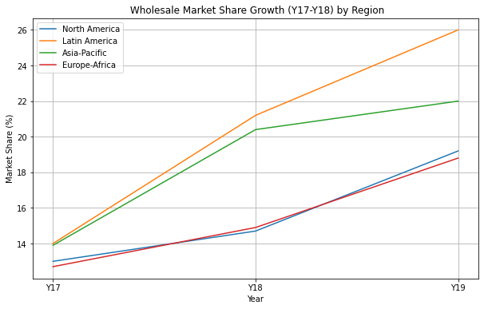

Finance: Despite maintaining a stellar credit rating under our management for years, we experienced a setback in Year 17, with our rating dropping from A+ to B+. This dip was a calculated risk we took to leverage industry-low interest rates. We aimed to utilize the available capital to pursue celebrity contracts and repurchase shares that had also experienced a decline. Fortunately, this gamble proved successful as we secured the desired celebrity endorsements. Subsequently, we swiftly course-corrected, leading to the restoration of our credit rating to its former A+ status.

Operations: We've decided to transition our factory production from private-label to branded products due to the intense competition of the private-label market. It has become a battleground solely focused on price, resulting in the loss of orders over mere cents. This fierce competition has eroded our margins and led to financial losses, with our production costs of $25 per shoe going to waste. In light of this uncertainty and the diminishing profitability, we've made the strategic decision to pivot towards maximizing our branded production.

**North America**

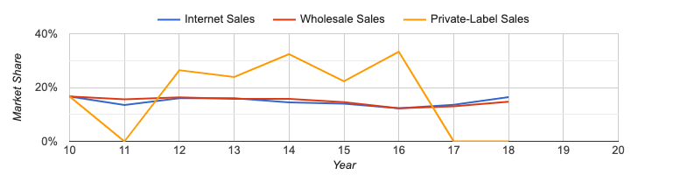

**Europe-Africa** 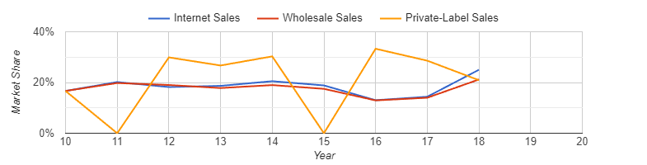

**Asia-Pacific** 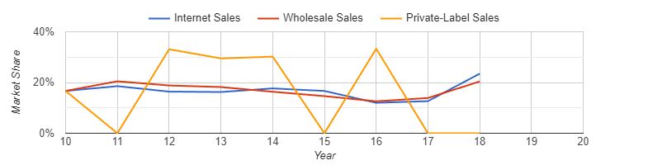

**Latin-America**

CSR: Our overarching objective is to reaffirm our commitment to corporate social responsibility (CSR) as we strive to realign our company with its founding values. In recent times, our CSR initiatives have unfortunately taken a back seat. Now, we are dedicated to reinstating our corporate citizenship and ensuring that it remains a central focus as we work towards restoring our company to its former stature.

**External Analysis**

**PESTEL Analysis**

This PESTEL analysis explores the political, economic, social, technological, environmental, and legal factors that impact the company's strategic decision-making and business operations. Please read each section below for a PESTEL analysis on the shoe industry..

**Political:** Dream Footwear operates in an environment influenced by various *trade agreements*. Changes in trade agreements can impact the company's supply chain, import/export regulations, and market access. For instance, shifts in trade policies or new agreements may lead to changes in tariffs, affecting production costs and pricing strategies (elaboration found in the Economic Factors in the next section). Additionally, trade agreements can influence the availability of raw materials and components, impacting production efficiency and overall business operations.

**Economic:** *Tariffs, exchange rates, interest rates, and inflation rates* have the ability to impact the companies’ operations and financial performance, where changes in tariffs can directly affect production costs and pricing strategies, especially for imported materials or finished products. Fluctuations in exchange rates can influence international sales and profitability, as they impact the cost of goods sold and foreign currency transactions. Moreover, variations in interest rates and inflation rates can affect borrowing costs, investment decisions, and consumer purchasing power, thereby influencing overall demand for footwear products.

**Social:** The shoe industry is also deeply influenced by social factors such as *fashion trends, health trends, and cultural/celebrity influences*. Consumer preferences for fashionable and trendy footwear drive demand and market positioning. Health trends, including a growing focus on comfort and sustainability, influence product designs and material choices. Additionally, cultural and celebrity influences play a significant role in shaping brand perception and consumer behavior, impacting purchasing decisions and brand loyalty.

**Technological:** Technological advancements play a crucial role in operations, particularly in terms of *factory improvements* and production strategies. Investments in automation, robotics, and digital technologies enhance manufacturing efficiency, product quality, and supply chain management.

**Environmental:** *Sustainability initiatives* are becoming increasingly important in the context of environmental considerations. Efforts to use eco-friendly materials, reduce carbon footprint, and adopt sustainable practices align with consumer preferences and regulatory requirements. These initiatives not only contribute to environmental conservation but also enhance brand reputation and help attract environmentally conscious consumers.

**Legal:** Compliance with *employment laws* regarding working conditions, fair wages, and employee rights is a fundamental aspect of any company’s operations. Ensuring ethical labor practices, maintaining safe working environments, and upholding fair wages and employee rights are critical for employee satisfaction, retention, and overall business reputation. Adhering to legal requirements also minimizes legal risks, fosters a positive corporate image, and strengthens relationships with stakeholders, including employees, customers, and regulatory authorities.

**Porter’s Five Forces**

**Threat Of New Entrants–LOW**: The threat of new entrants in the global market under consideration is low. This situation arises because the market is dominated by six major players who have established strong market positions, making it difficult for new competitors to enter. These major players likely benefit from significant economies of scale, robust brand loyalty among customers, and possibly access to technologies or favorable supply chains that create high barriers to entry. The cost and challenges associated with establishing a foothold in such a competitive environment can be prohibitively high for new companies without substantial resources or unique innovations.

The dominance of these six major players stabilizes the market structure, potentially leading to less price competition and higher profitability margins for these established companies. For new entrants, the low threat level suggests that entering this market would require disruptive innovation, substantial investment, or strategies that differentiate them significantly from existing competitors. This dynamic could discourage new companies from entering the market, thereby maintaining the status quo and possibly limiting the pace of innovation and competitive pricing that often accompanies increased competition.

**Bargaining Power Of Buyers–HIGH**: The high bargaining power of buyers in this market is driven by low switching costs and limited product diversity. Buyers can easily switch between suppliers without much consequence, giving them significant leverage in negotiations. As a result, companies must compete fiercely on price and quality to attract and retain customers. This competitive pressure can lead to lower prices and profit margins for suppliers. To counter this, companies may need to innovate and differentiate their offerings to create more value for buyers. Additionally, strategies such as loyalty programs or integrated service solutions can help increase switching costs subtly. Overall, in this competitive landscape, companies must prioritize customer satisfaction and creative innovation to thrive.

**Bargaining Power Of Suppliers–HIGH**: In this market, the high bargaining power of suppliers is evident due to the presence of a single provider who controls the pricing of both basic and superior materials. This supplier’s dominant position allows them to adjust costs based on demand, effectively influencing market prices at their discretion. The parties affected by this force include the supplier themselves and the companies that depend on these materials to produce their goods and services.

The high bargaining power of this sole supplier can lead to increased production costs for companies, which might then pass these costs on to consumers in the form of higher prices. This situation can stifle competition and innovation as companies may have less budget to invest in new technologies or processes. In such a market, companies might need to explore alternative materials or suppliers (if possible), invest in supplier relationships to negotiate better terms, or even consider vertical integration to reduce their dependence on powerful suppliers. The dynamic ultimately shapes the competitive landscape, potentially leading to reduced consumer choice and higher prices.

**Rivalry Among Existing Firms–MED**: The medium level of rivalry among existing firms in this market is characterized by competitive cost strategies within specific groups, yet there remains enough market space for companies to meet current customer expectations. The primary parties involved are the competing firms within the market, each vying to capture or expand their share by optimizing cost strategies to offer the best value.

The moderate rivalry suggests that while competition exists, it's not excessively cutthroat, allowing firms some breathing room to operate profitably and meet consumer demands without engaging in destructive price wars. This scenario is beneficial for maintaining stability in the market and giving companies the opportunity to innovate and improve their offerings. However, as companies continue to optimize costs and refine strategies, the level of competition could intensify, which may shift the dynamics towards either higher competition or consolidation in the future. For now, companies can leverage this relative stability to strengthen their market positions, focus on customer satisfaction, and explore new market segments without the immediate threat of aggressive competitive undercutting.

**Threat Of Substitute Products–LOW:** The threat of substitute products for the shoe market is assessed as low. This conclusion suggests that there are few, if any, alternative products that could perform the same function as shoes, indicating a limited presence of competitive substitutes that might attract consumers away from traditional footwear.

The primary parties involved in this scenario are the shoe manufacturers and potential manufacturers of substitute products. Given the low likelihood of substitutes emerging, shoe manufacturers can operate with less fear of disruption from alternative products, allowing them to focus more on competition within the sector rather than external threats.

The low threat of substitutes means that existing shoe companies can potentially enjoy more stable market conditions and might have greater pricing power, as customers have fewer alternative options. However, it also means that companies should not become complacent. They must continue to innovate and improve their offerings to maintain their competitive edge and customer loyalty, as consumer preferences can evolve even in the absence of direct substitutes. This environment provides an opportunity for shoe companies to invest in brand development and customer engagement strategies to solidify their market position further.

**Strategic Group Map/Predict Moves of Rivals**

Front Runner and Alpha Shoe Company are experiencing a divergence, positioning our company strategically in the midst of industry shifts. Given the trend of rivals leveraging celebrity endorsements to boost their market presence, it's imperative that we capitalize on this tactic without delay. As a team, we must maintain vigilant oversight on our cost structures and revenue streams, ensuring prudent financial management without resorting to drastic measures. We plan to reinvest dividends and initiate share buybacks to enhance shareholder value.

To improve our profit margins, we have strategically acquired a new factory, which may impact our market share temporarily. However, with competitors aggressively expanding, our focus must remain on optimizing margins to ensure financial health. Balancing our debt-to-equity ratio is crucial, and while eliminating debt entirely would be ill-advised, exploring a debt-equity swap could offer a viable financial restructuring strategy.

An audacious approach is considered to capture additional market shares from the four main competitors. Moving forward, our objectives are clear: 1.) Increase profit margins through cost reduction, 2.) Assertively secure our market position, and 3.) Develop a robust strategic plan that not only advances our competitive standing but also addresses any skepticism, reinforcing our commitment to both operational excellence and strategic growth.

**Competitive Strengths Assessment**

Year 14

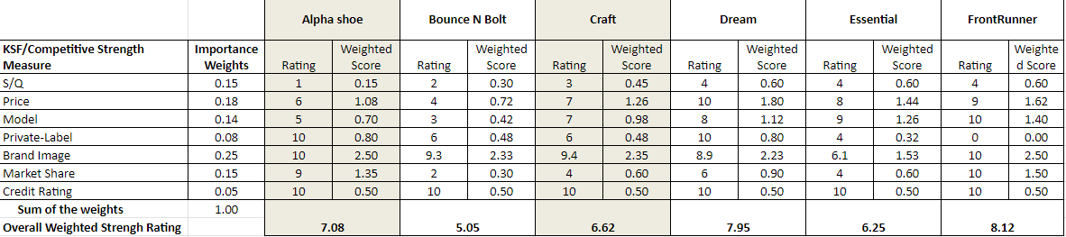

Year 19

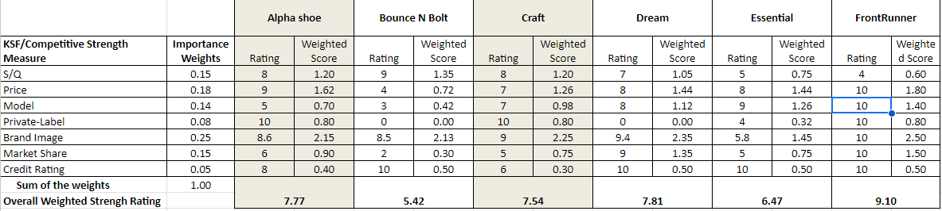

Significant shifts have occurred within the market, particularly evident in S/Q rating, private-label dynamics, and market share distribution. FrontRunner emerges as the unequivocal market leader, dominating through strategic pricing and model optimization initiatives, alongside a formidable presence in the private-label segment. Meanwhile, Alpha Shoe has executed a pivot, offering their product at a lower price point while preserving quality standards. Dream has also repositioned its strategy, raising prices and enhancing S/Q to transition into a best-cost provider role, concurrently scaling back production in the private-label sector.

**Key Success Factors**

**S/Q-** SQ trends in the market have been characterized by two predominant themes: a focus on either low model high S/Q or high model low S/Q approaches. Alpha Shoe and BounceNBolt have adopted the former, prioritizing quality over quantity in their offerings. Meanwhile, FrontRunner and Essential lean towards the high model strategy, emphasizing a wide array of options. Dream and Craft occupy a middle ground between these two extremes, with Craft leaning towards higher S/Q and fewer models compared to Dream's which is on the other side of the spectrum.

**Price-** Price trends in the market have shown consistency, with FrontRunner maintaining its position as the lowest-price provider. However, notable shifts have occurred elsewhere: Dream has transitioned towards a best-cost pricing strategy, while Alpha Shoe has significantly reduced its price point compared to previous offerings.

**Model-** Model availability in the market has shown stability, with Frontrunner and Essential consistently offering the most extensive range of models. On the other hand, Alpha and BounceNBolt have maintained a limited selection, while Craft and Dream fall somewhere in between these two extremes.

**Private Label-** The landscape of private-label has undergone the most significant transformations among all Key Success Factors (KSF), with all six companies vying for a slice of the market at one juncture. Ultimately, Alpha Shoe, Craft, and FrontRunner emerged on top, surpassing the competition. Meanwhile, Dream and BounceNBolt opted to exit the market entirely.

**Brand Image-** Brand image remains the pivotal force driving success within the industry, demonstrating a direct correlation with sales growth. Notably, companies that excel in this realm also lead in securing celebrity endorsements, effectively leveraging their appeal to expand market share.

**Market Share-** Minor shifts have been observed within the market, with Dream Footwear standing out notably by leveraging their enhanced brand image and celebrity endorsements to secure a significant market share. Meanwhile, FrontRunner maintains its position as the industry leader, retaining the majority share of the market.

**Credit Rating-** As the industry’s growth has slowed down, credit ratings have dipped among the industry. Most companies have been able to maintain their rating, proving to be reliable and creating greater competition within the industry.

**External Analysis Conclusion**

Our detailed analysis using PESTEL and Porter's Five Forces has provided a deep understanding of how Dream Footwear operates. These insights are guiding us as we navigate the complexities of the highly competitive shoe industry, from fluctuating political and economic climates to evolving social trends and technological advancements.

Our strategic focus is clear. We are leveraging our strengths to optimize efficiency and strengthen financial health. For instance, the acquisition of a new factory and strategic adjustments to our debt-equity ratio are calculated moves to enhance our market position and profitability. Looking ahead, we are determined to secure our market presence aggressively, streamline costs for improved profit margins, and develop a comprehensive strategy that not only advances our competitive stance but also addresses any potential concerns you, as our investors and stakeholders, might have. These are exciting yet challenging times, and we are committed to making strategic decisions that ensure the long-term success and sustainability of Dream Footwear.

**Internal Analysis**

**Assessment of Current Strategy (Financial Ratios)**

In this section, we conduct a comprehensive assessment of Dream Footwear's current business strategy by analyzing key financial ratios outlined in Figure 3.1 (found below). These ratios provide valuable insights into the company's profitability, asset utilization, liquidity, debt management, market valuation, and overall financial health. By examining trends and fluctuations in these metrics over the past ten years, we aim to evaluate the effectiveness of our strategic initiatives and identify areas for potential improvement or optimization. This analysis will continue to guide us towards enhancing financial performance, mitigating risks, and capitalizing on growth opportunities.

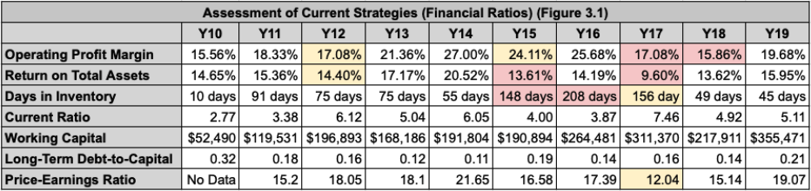

We have excelled in maintaining a healthy level of profitability, as evidenced by fluctuating but generally strong operating profit margins over the years. Peaks in profitability during Y14 and Y15 indicate successful periods, possibly due to effective cost management or increased sales initiatives. However, the recent declines in Y17 and Y18 highlight potential challenges in sustaining consistent profitability, signaling the need for strategic adjustments in pricing strategies, cost controls, or revenue generation approaches to mitigate these fluctuations and ensure long-term profitability.

Additionally, we have demonstrated commendable liquidity and financial health, with consistently high current ratios above 1 and an increasing trend in working capital until Y17. These metrics reflect the company's ability to meet short-term obligations with current assets and maintain sufficient liquidity reserves for operational needs and growth opportunities. However, the slight decrease in working capital in Y18 suggests a need for continued vigilance in managing liquidity to support ongoing business activities effectively.

Furthermore, our conservative approach to debt management is evident in our consistently low long-term debt-to-capital ratios. This strategy has contributed to financial stability, reduced interest expenses, and minimized the company's reliance on long-term debt for financing. Maintaining this prudent debt management approach is crucial for sustaining financial resilience and flexibility, especially in navigating economic uncertainties or capital-intensive expansion initiatives.

From a market perspective, the Price-Earnings (P/E) ratios reflect varying investor sentiments and market valuations over time. Higher P/E ratios in Y15 and Y19 indicate favorable market perceptions or expectations of future growth potential. However, the absence of data for Y10 and fluctuations in subsequent years highlight potential volatility in market sentiment or earnings performance, underscoring the importance of consistently delivering strong financial results and transparent communication with investors to enhance market valuation and investor confidence.

**Key Resources and Capabilities (VRIN)**

In this section, we explore Dream Footwear's strategic analysis using the VRIN model, a framework that assesses the company's competitive advantages based on factors of Value, Rarity, Inimitability, and Non-Substitute. By referencing Figure 3.2 (found below), which provides a detailed breakdown of Dream Footwear's VRIN assessment across key dimensions such as brand reputation, product quality, production costs, and design/technology, stakeholders can gain a comprehensive understanding of the company's strategic strengths and areas for strategic focus.

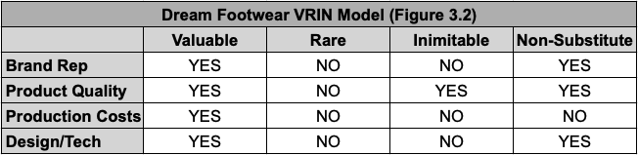

Dream Footwear's VRIN model analysis reveals several key insights into the company's competitive advantages and strategic positioning. Firstly, the brand's reputation emerges as a valuable asset, contributing to customer trust, loyalty, and market recognition. While brand reputation is not inherently rare or inimitable due to industry competition, its importance as a non-substitute factor cannot be overlooked, as strong brand perception often drives consumer preferences and purchasing decisions, especially in the fashion and lifestyle sectors.

Secondly, Dream Footwear's emphasis on product quality aligns with a valuable attribute that resonates with customers seeking durable, stylish, and comfortable footwear. However, the rarity and inimitability of this factor may be lower compared to other elements, as competitors can also offer high-quality products. Nonetheless, maintaining a consistent focus on delivering exceptional product quality remains crucial for sustaining customer satisfaction and loyalty.

Regarding production costs, while low production costs contribute to profitability and financial performance, they are not rare or inimitable factors, as competitors can also optimize their production processes. However, the value of low production costs cannot be understated, as they directly impact profit margins and operational efficiency, making them a valuable but substitutable advantage.

Lastly, Dream Footwear's focus on design and technology presents an intriguing aspect of the VRIN analysis. Innovative design and technological features can add value to the brand, attract customers, and differentiate products from competitors. Depending on the uniqueness and protectability of these design and technology aspects, they may possess elements of rarity and inimitability, making them potential sources of sustainable competitive advantage.

**SWOT Analysis**

**Strengths:** Dream Footwear excels in product quality, leveraging high-grade materials and meticulous craftsmanship to produce durable and comfortable footwear. This commitment to excellence not only fosters customer loyalty but also enhances the brand's reputation for reliability and superior performance. Additionally, Dream Footwear benefits from efficient production processes that result in low production costs, enabling the company to maintain healthy profit margins and allocate resources towards innovation and strategic initiatives.

**Weaknesses:** Despite its strengths, Dream Footwear faces certain weaknesses that acquire attention. One key area is its limited market share, indicating opportunities for expansion and market penetration. To address this, we will focus on enhancing its marketing strategies to reach new demographics, diversifying its product offerings to cater to varied consumer preferences, and exploring collaborative ventures with influencers or complementary brands to amplify brand visibility and attract a broader customer base.

**Opportunities:** Collaborations and partnerships with celebrities or industry influencers will offer a more compelling avenue to broaden the brand's reach and appeal to a wider audience segment. By leveraging these partnerships strategically, we can reach new markets and strengthen its brand image. Moreover, investing in robust brand marketing initiatives, including digital campaigns, experiential activations, and targeted advertising, presents opportunities to elevate brand awareness, foster brand loyalty, and drive sales growth.

**Threats:** Economic uncertainties, such as fluctuations in consumer spending habits and market conditions, pose a significant risk to discretionary spending on footwear. To mitigate this threat, we need to maintain financial agility, monitor market trends closely, and adapt pricing and promotional strategies accordingly. Furthermore, intensifying competition within the footwear industry necessitates continuous innovation, differentiation, and customer-centric approaches to remain resilient and relevant amidst evolving market dynamics.

**Value Chain**

Supply Chain Management: Our strategic approach to supply chain management involves carefully managing incremental increases in material, shipping, and warehousing costs to ensure they remain just below industry leaders, supporting our competitive pricing while maintaining superior quality. This methodical incrementality aids in stable financial planning and enhances our market positioning by balancing cost efficiency with high-quality offerings that appeal to price-sensitive yet quality-conscious customers. Simultaneously, this strategy strengthens our supply chain resilience by mitigating risks such as supply disruptions and escalating tariffs, thereby sustaining our brand loyalty and ensuring future market success. By focusing on these areas, we maintain a strong competitive edge and prepare for sustainable growth in an ever-changing market environment.

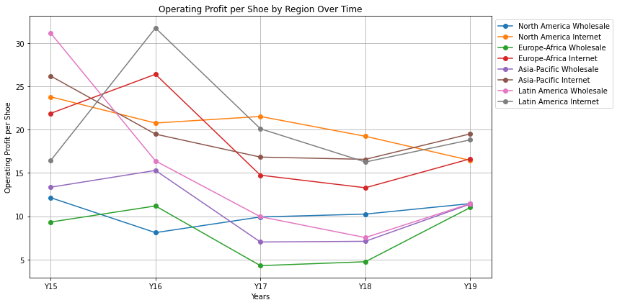

Operations: In the early stages of our venture, managing the Private-Label segment presented significant challenges, yet it also offered a unique competitive edge as few competitors initially invested heavily in this area. This early adoption positioned us advantageously, allowing us to capitalize on the limited competition. However, as time progressed, other teams recognized the potential of Private-Label, leading to increased investments in this segment across the industry. This shift turned our initial advantage into a considerable mountain to climb, intensifying competition and diminishing our unique market position. Ultimately, it became evident that our Private-Label operations would not sustain the high revenue projections we initially anticipated, as the market became saturated and competitors leveraged similar strategies to attract a shared customer base. This evolution from a strategic advantage to a competitive norm underlines the dynamic nature of market forces and the need for continuous adaptation in our industry.

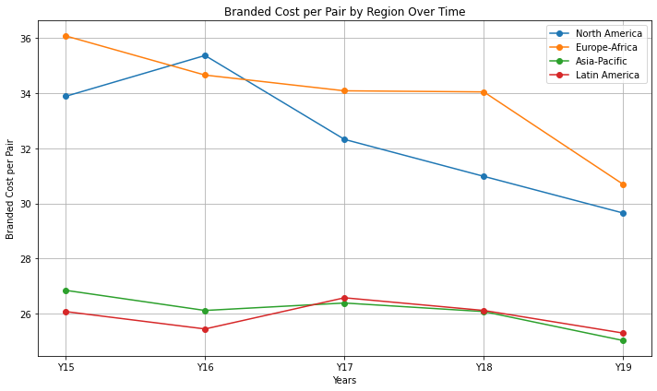

Distribution: Over time, distribution costs have steadily risen due to the increased production necessary to meet market demand. This shift has compelled us to import more shoes into North America and Europe-Africa. While this incurs additional expenses, it's a necessary step to maintain our margins.

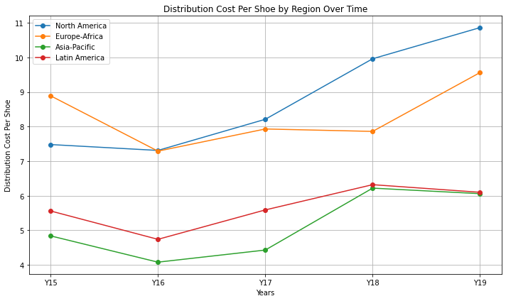Sales & Marketing: Our current sales and marketing strategy is focused on taking the offensive. This proactive approach is evident in the increased investment across all regions, particularly in year 18 when we initiated our aggressive campaign to capture market share from our competitors through our celebrity endorsements and brand marketing. The dips in year 19 are from a slight adjustment to retailer support.

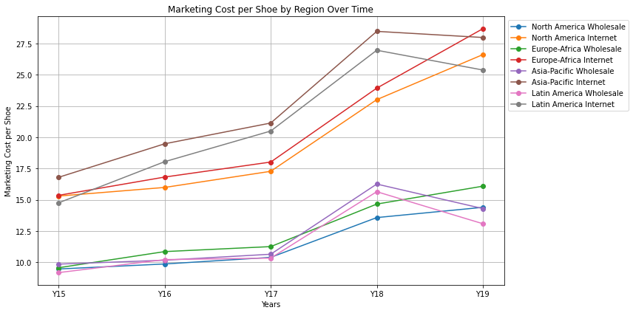

**Internal Analysis Conclusion**

In conclusion, our internal analysis of Dream Footwear's current strategy provides a comprehensive understanding of our competitive strengths and areas for improvement. Through the assessment of key financial ratios, we have identified trends in profitability, liquidity, and debt management, guiding strategic decisions to optimize financial performance and mitigate risks effectively. Additionally, the VRIN model analysis has shed light on our core abilities, highlighting valuable assets like brand reputation, product quality, and potential for unique design and technology innovations. Leveraging these strengths will be crucial in addressing weaknesses such as limited market share, through strategic collaborations and targeted marketing initiatives outlined in our SWOT analysis.

Our value chain analysis underscores the strategic importance of supply chain management, operations, distribution, and sales & marketing in maintaining competitive positioning and driving sustainable growth. By aligning our internal capabilities with market opportunities and strategic insights, we are well-positioned to enhance agility, innovation, and customer-centric focus for long-term success in the dynamic footwear market.